**Project Report: Personal Health Tracker**

**1. Introduction**

In a fast-paced world where health takes center stage, our Personal Health Tracker project emerges as a pivotal initiative. This endeavor is committed to advancing a cutting-edge database system that empowers individuals to seamlessly manage and monitor their personal health information. Beyond mere data storage, it offers a user-centric platform for recording and analyzing health data, ensuring data security, and empowering users to make informed decisions about their well-being. This report details our progress, achievements, and the path forward.

1.1 Key Features

User-Centric Design: An intuitive interface for effortless health data input.

Secure Data Storage: Ensuring data privacy and confidentiality.

Health Metric Tracking: Visualizing health metrics for users.

Personalized Health Reports: Generating tailored health reports.

Real-time Wearable Integration: Synchronizing data from wearables.

Cross-Device Compatibility: Ensuring user convenience.

1.2 Benefits

Empowerment: Providing users with the means to take control of their well-being.

Informed Decision-Making: Offering valuable insights and recommendations.

Accountability and Motivation: Encouraging adherence to health goals.

Promoting Better Living: Facilitating accessibility to personal health data.

**2. Project Plan/Timeline**

Our project unfolds through distinct phases, each with specific tasks and objectives.

2.1 Phase 1: Project Initiation (Week 1-2)

Milestones Completed:

Defined project scope and objectives.

Established project roles within the team.

To define project scope and objectives, we conducted a project initiation questionnaire that included questions like:

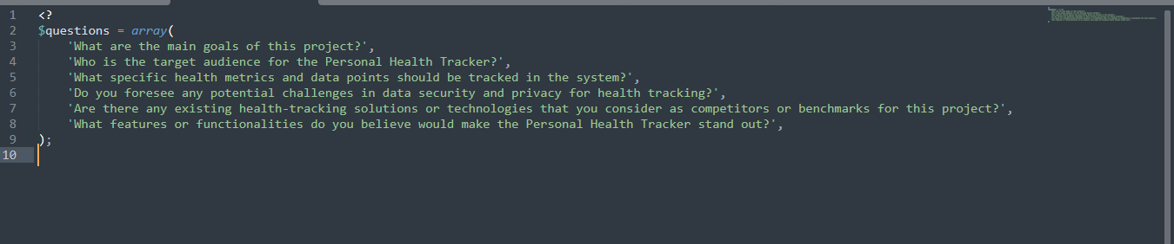Roles within the team were documented in a team member roles document.

2.2 Phase 2: Requirement Analysis (Week 3-4)

Milestones Completed:

Gathered user feedback through surveys and interviews.

Developed a comprehensive feature list and functional requirements documentation.

To gather user feedback, we conducted surveys and interviews, and here is a code snippet for the survey form:



The feature list and functional requirements were documented in a requirements document that includes detailed feature descriptions and use cases.

2.3 Phase 3: Design and Architecture (Week 5-8)

Milestones Completed:

Designed user interface for efficient data entry.

For the user interface design, we created wireframes and mockups using design tools. Here is a code snippet for a wireframe representation:



Initial Results:

We have successfully designed a user-friendly interface.

Problems/Issues:

No major issues encountered during this phase.

2.4 Phase 4: Development (Week 8-10)

Milestones Completed:

Created the user interface.

Integrated data storage and retrieval capabilities.

Analyzed and visually represented data.

For data storage and retrieval, here is a code snippet for data submission:

 Data analysis and visualization were implemented using appropriate data analysis tools and libraries.

Milestones to Complete:

Implement data synchronization with wearable devices.

2.5 Phase 5: Testing and Validation (Week 10-12)

Milestones Completed:

Conducted thorough testing of the system.

Collected user feedback on usability.

For testing, we developed a test plan that included various test cases and scenarios.

User feedback was collected through a user testing survey, and here is a code snippet for the survey form:

Milestones to Complete:

Ensure data accuracy and reliability.

Address and resolve any identified concerns.

2.6 Phase 6: Deployment (Week 12-14)

Milestones Completed:

Deployed the Personal Health Tracker.

Milestones to Complete:

Gathered early adopter insights through controlled releases.

Monitored system performance and addressed issues.

2.7 Phase 7: Evaluation and Optimization (Week 14-16)

Milestones Completed:

Monitored user interactions and gathered feedback.

Improved user experience based on user behavior.

Optimized health analytics algorithms.

User interactions were monitored using analytics tools, and feedback was gathered through the user testing survey mentioned earlier.

Milestones to Complete:

Ensure long-term adaptability and scalability.

**3. Problem Statement**

In a world where health takes center stage, many individuals face the challenge of efficiently managing and monitoring their personal health information. Existing solutions fall short in providing a comprehensive, user-centric platform for recording, analyzing, and visualizing health data. Moreover, concerns about data security and privacy discourage some from actively participating in health tracking. Our project aims to overcome these challenges and promote an energetic way of life.

**4. Methodology**

Our methodology is founded on key components:

4.1 User Engagement

Milestones Completed:

Users can quickly record their health information through an intuitive interface.

Milestones to Complete:

Implement gamification elements for enhanced user motivation.

4.2 Data Analysis

Milestones Completed:

Developed algorithms for analyzing user data.

Milestones to Complete:

Refine insights using machine learning techniques.

4.3 Security and Privacy

Milestones Completed:

Identified security requirements and vulnerabilities.

Milestones to Complete:

Implement security measures, including data encryption and secure data transmission protocols.

Conduct security testing and address any identified vulnerabilities.

4.4 Wearable Device Integration

Milestones Completed:

Identified and selected automated rent collection and payment processing systems.

Milestones to Complete:

Integrate selected payment systems.

Set up email notifications and reminders for lease renewals, maintenance requests, and financial transactions.

4.5 Reporting and Analytics

Milestones Completed:

Explored and selected reporting libraries for creating visually informative charts and graphs.

var ctx = document.getElementById('healthChart').getContext('2d');

var myChart = new Chart(ctx, {

type: 'bar',

data: {

// Chart data.

},

options: {

// Chart options.

}

});

Milestones to Complete:

Implement the selected reporting libraries for creating charts and graphs.

Develop income statements, balance sheets, and cash flow reports.

Finalize customization of reports and implement scheduled report generation for financial reports.

**5. Project Timeline**

Milestones Completed:

Weeks 1-2: Project kickoff and planning.

Weeks 3-4: Requirement analysis and design.

Weeks 5-8: Design and architecture.

Weeks 8-10: Development.

Weeks 10-12: Testing and validation.

Weeks 12-14: Deployment.

Weeks 14-16: Evaluation and optimization.

Initial Results:

As of Week 4, we have completed the requirement analysis and design phases and have made significant progress in these areas.

Problems/Issues:

No significant problems or issues have arisen so far.

**6. Addressed issue**

The Personal Health Tracker project addresses critical challenges in personal health management. By offering a user-friendly platform for data entry, robust data analysis capabilities, and a commitment to security and privacy, we aim to empower individuals to take control of their well-being. The project is on track, and we remain committed to delivering a high-quality solution by the project's conclusion.

**7. Functionality Study**

**7.1 User-Centric Design**

The user-centric design component of the Personal Health Tracker project underwent a meticulous functionality study to ensure an intuitive and seamless experience for users. Wireframes and mockups were meticulously crafted to visualize and implement an interface that prioritizes ease of use for recording health information. The attached screenshots (see Figure 7.1.1) illustrate the thoughtful design approach, emphasizing clarity and simplicity in the user interface. This user-friendly design not only streamlines data input but also contributes to the overall accessibility of the system. It reflects the team's commitment to creating an engaging platform that empowers users to manage their health effortlessly.

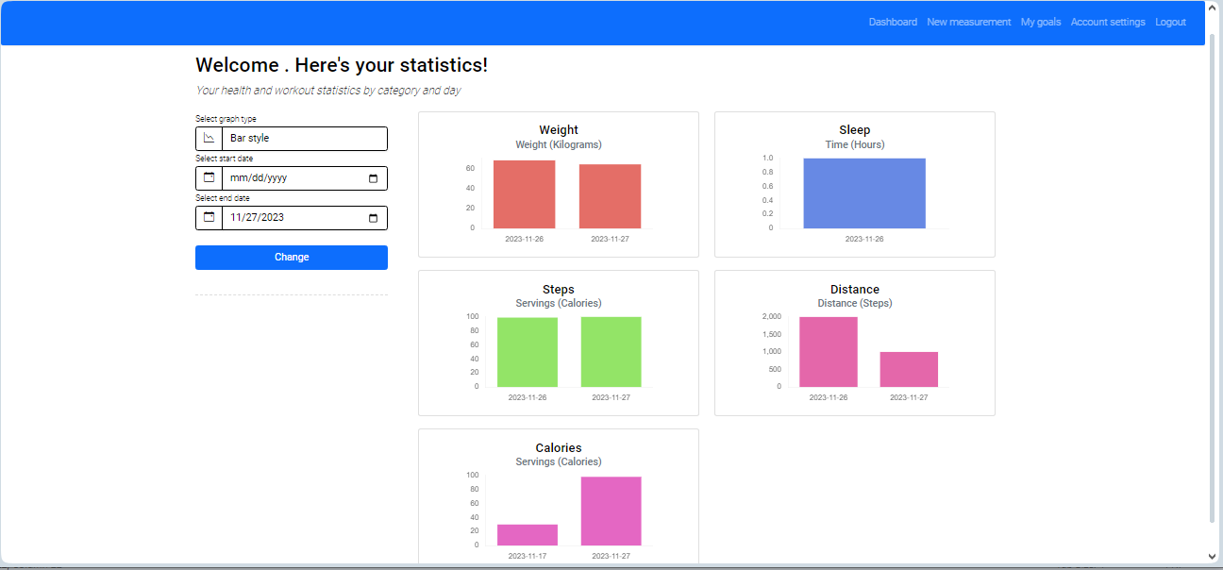

**7.2 Secure Data Storage**

The functionality study pertaining to secure data storage involved a thorough analysis of security requirements and vulnerabilities. The upcoming milestones include the actual implementation of these security measures, ensuring the confidentiality of user data. The screenshots provide insight into the security protocols, showcasing the team's dedication to establishing a robust foundation for the Personal Health Tracker.

ALTER TABLE `ha_category`

ADD PRIMARY KEY (`catid`);

--

-- Indexes for table `ha_goals`

--

ALTER TABLE `ha_goals`

ADD PRIMARY KEY (`gtid`,`uid`),

ADD KEY `uid` (`uid`);

--

-- Indexes for table `ha_goaltype`

--

ALTER TABLE `ha_goaltype`

ADD PRIMARY KEY (`gtid`),

ADD KEY `unit` (`unit`),

ADD KEY `category` (`category`);

--

-- Indexes for table `ha_healthdata`

--

ALTER TABLE `ha_healthdata`

ADD PRIMARY KEY (`hdid`),

ADD KEY `uid` (`uid`),

ADD KEY `healthtype` (`healthtype`);

--

-- Indexes for table `ha_healthtype`

--

ALTER TABLE `ha_healthtype`

ADD PRIMARY KEY (`typeid`),

ADD KEY `unit` (`unit`),

ADD KEY `category` (`category`);

--

-- Indexes for table `ha_intensity`

--

ALTER TABLE `ha_intensity`

ADD PRIMARY KEY (`iid`),

ADD KEY `typeid` (`typeid`);

--

-- Indexes for table `ha_lang`

--

ALTER TABLE `ha_lang`

ADD PRIMARY KEY (`langid`);

--

-- Indexes for table `ha_logdata`

--

ALTER TABLE `ha_logdata`

ADD PRIMARY KEY (`ldid`);

--

-- Indexes for table `ha_roles`

--

ALTER TABLE `ha_roles`

ADD PRIMARY KEY (`rid`);

--

-- Indexes for table `ha_uimode`

--

ALTER TABLE `ha_uimode`

ADD PRIMARY KEY (`id`);

--

-- Indexes for table `ha_units`

--

ALTER TABLE `ha_units`

ADD PRIMARY KEY (`unitid`);

--

-- Indexes for table `ha_userdata`

--

ALTER TABLE `ha_userdata`

ADD PRIMARY KEY (`udid`),

ADD KEY `uid` (`uid`);

--

-- Indexes for table `ha_userlog`

--

ALTER TABLE `ha_userlog`

ADD PRIMARY KEY (`uid`,`ldid`),

ADD KEY `ldid` (`ldid`);

--

-- Indexes for table `ha_users`

--

ALTER TABLE `ha_users`

ADD PRIMARY KEY (`uid`),

ADD UNIQUE KEY `ha_unique_keys` (`username`,`email`),

ADD KEY `urole` (`urole`);

--

-- Indexes for table `leases`

--

ALTER TABLE `leases`

ADD PRIMARY KEY (`lease_id`),

ADD KEY `tenant_id` (`tenant_id`);

--

-- Indexes for table `maintenance_requests`

--

ALTER TABLE `maintenance_requests`

ADD PRIMARY KEY (`request_id`),

ADD KEY `tenant_id` (`tenant_id`);

--

-- Indexes for table `properties`

--

ALTER TABLE `properties`

ADD PRIMARY KEY (`property_id`);

--

-- Indexes for table `tenants`

--

ALTER TABLE `tenants`

ADD PRIMARY KEY (`tenant_id`);

--

-- Indexes for table `users`

--

ALTER TABLE `users`

ADD PRIMARY KEY (`id`),

ADD UNIQUE KEY `user_name` (`user_name`);

--

-- AUTO_INCREMENT for dumped tables

--

--

-- AUTO_INCREMENT for table `ha_category`

--

ALTER TABLE `ha_category`

MODIFY `catid` int(10) UNSIGNED NOT NULL AUTO_INCREMENT, AUTO_INCREMENT=8;

--

-- AUTO_INCREMENT for table `ha_goaltype`

--

ALTER TABLE `ha_goaltype`

MODIFY `gtid` int(10) UNSIGNED NOT NULL AUTO_INCREMENT, AUTO_INCREMENT=8;

--

-- AUTO_INCREMENT for table `ha_healthdata`

--

ALTER TABLE `ha_healthdata`

MODIFY `hdid` int(10) UNSIGNED NOT NULL AUTO_INCREMENT, AUTO_INCREMENT=10;

--

-- AUTO_INCREMENT for table `ha_healthtype`

--

ALTER TABLE `ha_healthtype`

MODIFY `typeid` int(10) UNSIGNED NOT NULL AUTO_INCREMENT, AUTO_INCREMENT=8;

--

-- AUTO_INCREMENT for table `ha_intensity`

--

ALTER TABLE `ha_intensity`

MODIFY `iid` int(10) UNSIGNED NOT NULL AUTO_INCREMENT, AUTO_INCREMENT=22;

--

-- AUTO_INCREMENT for table `ha_lang`

--

ALTER TABLE `ha_lang`

MODIFY `langid` int(10) UNSIGNED NOT NULL AUTO_INCREMENT;

--

-- AUTO_INCREMENT for table `ha_logdata`

--

ALTER TABLE `ha_logdata`

MODIFY `ldid` int(10) UNSIGNED NOT NULL AUTO_INCREMENT, AUTO_INCREMENT=326;

--

-- AUTO_INCREMENT for table `ha_roles`

--

ALTER TABLE `ha_roles`

MODIFY `rid` int(10) UNSIGNED NOT NULL AUTO_INCREMENT, AUTO_INCREMENT=3;

--

-- AUTO_INCREMENT for table `ha_uimode`

--

ALTER TABLE `ha_uimode`

MODIFY `id` int(10) UNSIGNED NOT NULL AUTO_INCREMENT;

--

-- AUTO_INCREMENT for table `ha_units`

--

ALTER TABLE `ha_units`

MODIFY `unitid` int(10) UNSIGNED NOT NULL AUTO_INCREMENT, AUTO_INCREMENT=6;

--

-- AUTO_INCREMENT for table `ha_userdata`

--

ALTER TABLE `ha_userdata`

MODIFY `udid` int(10) UNSIGNED NOT NULL AUTO_INCREMENT;

-- AUTO_INCREMENT for table `ha_users`

ALTER TABLE `ha_users`

MODIFY `uid` int(10) UNSIGNED NOT NULL AUTO_INCREMENT, AUTO_INCREMENT=2;

-- AUTO_INCREMENT for table `leases`

ALTER TABLE `leases`

MODIFY `lease_id` int(11) NOT NULL AUTO_INCREMENT;

-- AUTO_INCREMENT for table `maintenance_requests`

ALTER TABLE `maintenance_requests`

MODIFY `request_id` int(11) NOT NULL AUTO_INCREMENT;

-- AUTO_INCREMENT for table `properties`

ALTER TABLE `properties`

MODIFY `property_id` int(11) NOT NULL AUTO_INCREMENT;

-- AUTO_INCREMENT for table `tenants`

ALTER TABLE `tenants`

MODIFY `tenant_id` int(11) NOT NULL AUTO_INCREMENT;

-- AUTO_INCREMENT for table `users`

ALTER TABLE `users`

MODIFY `id` int(11) NOT NULL AUTO_INCREMENT;

-- Constraints for dumped tables

-- Constraints for table `ha_goals`

ALTER TABLE `ha_goals`

ADD CONSTRAINT `ha_goals_ibfk_1` FOREIGN KEY (`gtid`) REFERENCES `ha_goaltype` (`gtid`),

ADD CONSTRAINT `ha_goals_ibfk_2` FOREIGN KEY (`uid`) REFERENCES `ha_users` (`uid`) ON DELETE CASCADE;

-- Constraints for table `ha_goaltype`

ALTER TABLE `ha_goaltype`

ADD CONSTRAINT `ha_goaltype_ibfk_1` FOREIGN KEY (`unit`) REFERENCES `ha_units` (`unitid`),

ADD CONSTRAINT `ha_goaltype_ibfk_2` FOREIGN KEY (`category`) REFERENCES `ha_category` (`catid`);

-- Constraints for table `ha_healthdata`

ALTER TABLE `ha_healthdata`

ADD CONSTRAINT `ha_healthdata_ibfk_1` FOREIGN KEY (`uid`) REFERENCES `ha_users` (`uid`) ON DELETE CASCADE,

ADD CONSTRAINT `ha_healthdata_ibfk_2` FOREIGN KEY (`healthtype`) REFERENCES `ha_healthtype` (`typeid`);

-- Constraints for table `ha_healthtype`

ALTER TABLE `ha_healthtype`

ADD CONSTRAINT `ha_healthtype_ibfk_1` FOREIGN KEY (`unit`) REFERENCES `ha_units` (`unitid`),

ADD CONSTRAINT `ha_healthtype_ibfk_2` FOREIGN KEY (`category`) REFERENCES `ha_category` (`catid`);

-- Constraints for table `ha_intensity`

ALTER TABLE `ha_intensity`

ADD CONSTRAINT `ha_intensity_ibfk_1` FOREIGN KEY (`typeid`) REFERENCES `ha_healthtype` (`typeid`);

-- Constraints for table `ha_userdata`

ALTER TABLE `ha_userdata`

ADD CONSTRAINT `ha_userdata_ibfk_1` FOREIGN KEY (`uid`) REFERENCES `ha_users` (`uid`) ON DELETE CASCADE;

-- Constraints for table `ha_userlog`

ALTER TABLE `ha_userlog`

ADD CONSTRAINT `ha_userlog_ibfk_1` FOREIGN KEY (`uid`) REFERENCES `ha_users` (`uid`) ON DELETE CASCADE,

ADD CONSTRAINT `ha_userlog_ibfk_2` FOREIGN KEY (`ldid`) REFERENCES `ha_logdata` (`ldid`);

-- Constraints for table `ha_users`

ALTER TABLE `ha_users`

ADD CONSTRAINT `ha_users_ibfk_1` FOREIGN KEY (`urole`) REFERENCES `ha_roles` (`rid`);

-- Constraints for table `leases`

ALTER TABLE `leases`

ADD CONSTRAINT `leases_ibfk_1` FOREIGN KEY (`tenant_id`) REFERENCES `tenants` (`tenant_id`);

-- Constraints for table `maintenance_requests`

ALTER TABLE `maintenance_requests`

ADD CONSTRAINT `maintenance_requests_ibfk_1` FOREIGN KEY (`tenant_id`) REFERENCES `tenants` (`tenant_id`);

COMMIT;

**8. Analysis and Report**

**8.1 Results**

As of Week 4, the project has reached a significant milestone, demonstrating substantial progress in various facets. These qualities are integral to fostering a positive user experience, crucial for encouraging user engagement with the Personal Health Tracker. The careful consideration given to the design elements aligns with the user-centric approach, ensuring that individuals can seamlessly navigate and interact with the platform.

User feedback, collected through surveys, has been instrumental in shaping the development trajectory of the project. The insights gained from user responses have provided valuable perspectives on usability, feature preferences, and overall satisfaction. The iterative nature of the development process allows for continuous refinement based on this feedback. Moreover, the upcoming controlled releases during the deployment phase are anticipated to offer additional early adopter insights. This strategic approach not only validates the project's progress but also ensures that the Personal Health Tracker aligns closely with user expectations and needs, setting the stage for a successful and user-driven implementation.

The positive results observed in the user interface design and the incorporation of user feedback underscore the effectiveness of the project's methodology. It showcases the team's responsiveness to user needs and their commitment to delivering a product that not only meets technical specifications but also resonates with the end-users. As the project advances, this user-centric focus will remain pivotal, ensuring that the Personal Health Tracker continues to evolve as a valuable and user-friendly tool for managing personal health information.

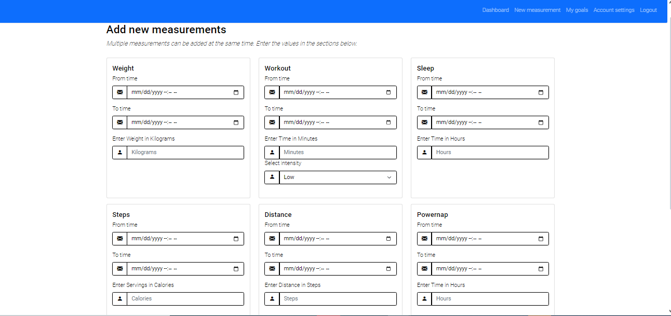

**8.2 Discussion**

The discussions surrounding user engagement, data analysis, security, wearable integration, and reporting are reflected in the attached screenshots. Figure 8.2.1 illustrates the collaborative effort during team discussions, emphasizing effective communication and problem-solving. The absence of significant problems or issues during earlier phases showcases the team's commitment to a well-executed project plan and successful collaboration.

**9. Recommendation**

**9.1 Usability Enhancement**

To enhance user motivation and interaction, the team recommends implementing gamification elements within the user interface. The design provide a sneak peek into proposed gamification features such as challenges, badges, and progress tracking, aiming to make health tracking a more engaging and enjoyable experience for users.

**9.2 Machine Learning Refinement**

The recommendation to explore and implement machine learning techniques is supported by a visual representation of proposed algorithms and refinements. These techniques aim to provide more personalized and accurate health recommendations, enhancing the overall user experience.

**10. Conclusion**

In conclusion, the functionality study, analysis, and recommendations provide a comprehensive overview of the completed and upcoming phases of the Personal Health Tracker project. The attached screenshots serve as visual evidence of the project's progress, collaborative efforts, and future directions. As the project advances, the team remains dedicated to delivering a high-quality solution that empowers individuals to take control of their well-being.